I’d like to take a moment and go over everything with you to help prepare you for his/her homecoming.

1. First, keep in mind that puppies are a lot like small children; they want to get into everything! Be sure to puppy-proof his/her surroundings! Below, I’ve provided a picture of an exercise pen that can be purchased at Petco, Petsmart, or even on Amazon; these are invaluable! They can be moved around and can easily set up indoors or outdoors. They are great for keeping them away from areas that are less likely to be “puppy friendly.”

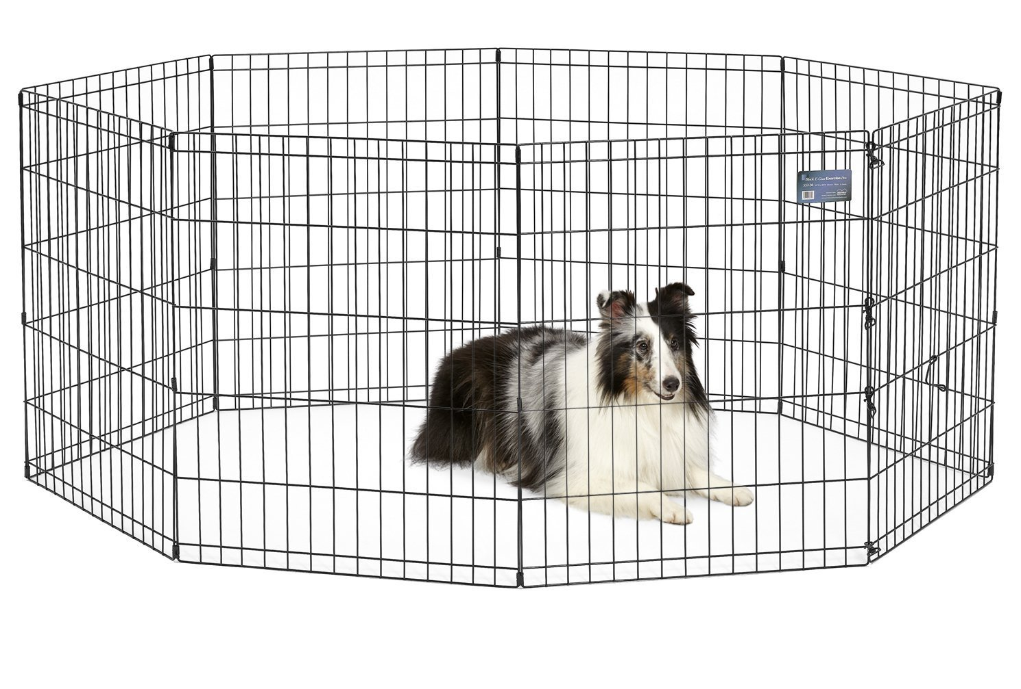

1. Potty Training- I’m often asked for advice on potty training methods. Honestly, that depends on you. There are several options out there and the Internet has tons of advice depending on which method you choose. We start out here by encouraging them to use the shavings in the rear of their nursery pen. This seems to make the transition between the nursery and your home a little easier. I have provided a picture below to show you our setup in their nursery pens incase you haven’t already seen it. It doesn’t necessary mean they will be 100% potty trained…I only wish that was the case…you will need to continue to encourage your pup to go potty outside. This takes being aware and making certain that while he is young and his bladder is small, that you take him out more often. (A general rule of thumb is for every 4 weeks of age, he has a 1 hour window therefore a 2 month old pup has a 2 hour window between potty breaks) Some times even placing some shavings in the location you prefer him to potty can help with this transition. Shavings can be purchased at your local feed store.

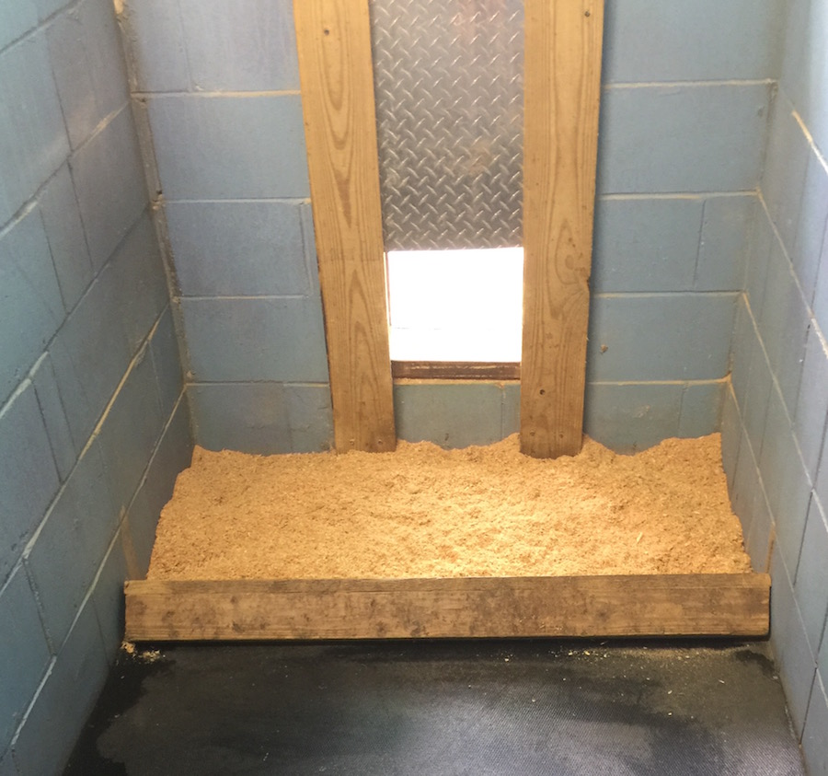

1. Puppy Booster Vaccines-When you pick up your little fur-baby, he/she will be current on all his vaccines to date! BUT, he/she will still need his booster vaccines! **This is extremely important! Sure, he/she does already have some protection but will not be fully protected until the immune system has completed all the necessary puppy booster vaccines**. On the health card that will be provided with your pup’s paperwork, you will see at the bottom of it, there’s future dates written; these are the dates when the boosters will need to be given. Go ahead and contact your vet to them set up. Keep in mind that a lot of vets sell puppy vaccination packages so be sure to ask. It may save you a little money in the long run.
2. Flea Prevention-Because your pup is so young; I choose not to apply any topical flea meds. I realize that there are several topical flea treatments that claim to be safe for puppies but I’m still not 100% convinced. I’ve noticed some of my pups get very itchy after a treatment and I’ve even had customers request that none be put on their pup, so with that said, I will leave it up to you and your vet to decide what is in the best interest of your pup. There are lots of options on the market today including more natural methods like the Diatomaceous Earth. A lot of the oral flea medications work wonderfully but in many cases your pup has to be much older and meet a certain weight requirement prior to use. I personally use Bravecto with my adult dogs. It’s a 3 months preventative and I’ve been very happy with the results so far. I’ve had several customers use NexGard and rave about it; it is a monthly preventative.
3. Neutering/Spaying-This is another question I’m often asked about. I’m all for it!!! Life will be so much easier for both you and your pup in the long run! Not just disposition wise but also health wise!!! Please do a Google search on benefits of neutering/spaying your dog! There’s lots of information as to why this will be in his best interest. When to neuter? Now that is the toughest question to answer! There are different opinions on this subject. My vet says try to wait until their at least 4 months old so that they’ve completed all of their puppy boosters for immune protection. I tell my customers to talk to your vet; find out what he or she recommends. Don’t be afraid to do a little homework on the worldwide web first so you can address any questions or concerns you may have with your vet.
4. Dog foods-Holy cow…there are so many dog food options on the market nowadays I don’t even know where to start!!! I personally feed the Victor High Pro-Plus to my puppies. They do well on it and they really seem to like it! I will be sending a 5# bag with your pup so that he will not have to make any quick adjustments if you do need to eventually switch him onto something different. He has been on free-choice food here since he has littermates to share with but you may choose to eventually place him on a feeding schedule. If you do this, I recommend no less than 3 meals a day since he is a growing pup. Victor dog food has a great website with lots of information at [www.Victordogfood.com](http://www.Victordogfood.com) Be sure to check your location on their website to see if it is sold in your area. If there is no location near you it’s okay, you should have plenty of food from the bag I give you to make the change on to a food of your preference or you can order Victor Pro-Plus online. Whatever you decide, just be sure to stick with a good quality puppy food.

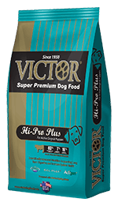

1. NuVet Plus K-9 Wafers-This past year I had several customers ask me if I had ever heard of a vitamin called NuVet Plus K-9 Wafers. They swore by them and of course, out of curiosity I had to check it out. After checking at this company’s website and reading tons of wonderful reviews, I gave them a call. After about an hour or so on the phone with a gentleman, I decided to add these vitamins to my lineup. It’s totally optional to my customers but I really wanted to see the benefits these vitamins may have on my puppies. With that being said, I have decided to extend my hereditary health guarantee an additional year making it three years instead of two for each pup that is given these vitamins through his first birthday. I will attach a letter with more information on this product.
2. Micro-chipping- I now include the microchipping in the cost of your puppy! I have joined with AKC Reunite to provide you the best protection for your new fur-baby! It is already prepaid so all that I ask you to do is take a few minutes and sign onto their online site and update all of your information with the chip number enclosed in your packet. It’s simple and easy!
3. Registration~~If your pup is AKC registered, please go online and register he/she into your name immediately!! There is a PIN number on your registration certificate that you will use to do this and it won’t take long at all. You will have the added benefit of one month free pet insurance & a free vet visit to a vet in your area but only if you complete this process!
4. Look for these items to be included in your puppy package at time of pick up:
   1. 5# bag of Victor High Pro-Plus
   2. Registration Certificate
   3. Veterinary Health Certificate
   4. Health Records
   5. Puppy Instructions
   6. Puppy Pee Pad
   7. AKC Reunite Microchip Information
   8. Toy
   9. Heartgard Puppy Kit
5. **Pick-up Date- Please email or text me (352-266-0282) back with the date you would like to pick up your pup with an approximate time. This really helps me plan ahead. I want to make sure I’m not going to have one pup left alone when all the others are gone. I can always place momma back with him or buddy him up with another pup but it’s good to know in advance.**
6. **Final Payment-Last but not least, if you have not already done so…I would be very grateful if you could go ahead and make your final payment. This really helps me finalize all my records on this end and pay the vet at the time of our visit instead of having to do so at a later date. BELOW ARE LIST OF PAYMENT OPTIONS**
   1. **If you’re paying using PayPal, please send your payment to** [**Jodi@butterballkennel.com**](mailto:Jodi@butterballkennel.com) **(you may’ve sent it to my other for your deposit which was** [**Gray7182@aol.com**](mailto:Gray7182@aol.com) **) and be sure to check the option for paying a friend or family member so that it does not remove any fees on my end.**
   2. **VENMO-my account is Jodi Gray @ButterballKennel- I can send you a payment request if you prefer to pay this way; just let me know.**
   3. **Apple Pay-I can send you a payment request if you prefer to pay this way; just let me know.**
   4. **If you’re paying with a credit card, I will have to add an additional 3% fee onto the balance to cover the fees I get charged through the credit card company**
   5. **If you are picking your pup up, and you are unable to pay by any of the methods above and you prefer not to use a credit card, then I can only accept cash at that time; no checks.**

If you have any questions or concerns, please do not hesitate to contact me! My cell is (352) 266-0282 or you can email me at [Jodi@butterballkennel.com](mailto:Jodi@butterballkennel.com)

As always, thank you for your business and for providing a wonderful home and family for one of our precious Butterball’s! Also I am available 24/7 if you ever have any questions or concerns. And feel free to text pictures of your pup anytime! ☺

Jodi & The Jacks!